DIVISION OF ADMINISTRATIVE OPERATIONS
WALK THRU METAL DETECTORS & HAND WAND PROCEDURES

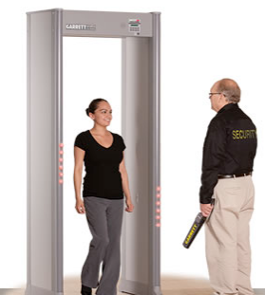

CAUTION: The information contained in this policy and procedure document has been complied to serve to serve as a guide, and not intended to substitute your site-specific post order.
PURPOSE
To provide guidance and direction to Security Guard(s) assigned to all Department of Human Services Facilities for routine access and screening procedures for controlling prohibited items being brought into government facilities.
SCREENING PROCEDURES SHOULD:
- Outline how to conduct a proper patron screening;
- Describe how to interact with individuals being searched;
- State how to identify prohibited items during the screening; and
- Describe how to respond to items discovered during the screening.
SIGNIFICANCE AND USE
Security personnel may employ multiple layers of screening to prevent the unauthorized introduction of unlawful items into a client protected government facility. Screening devices often serve as an effective and less intrusive means for searching for unauthorized items. Commonly employed screening methods include the following.
- Walk- Through Metal Detector
- Hand-Held (WAND) Detector
The above-mentioned devices are often employed to prevent the unauthorized entry of weapons into facilities and/or unauthorized removal of client property. Routine functional testing of mechanical and electronic screening devices ensures continued functionality.
SCANNING PROCEDURES WITH A WALK-THRU METAL DETECTOR
As previously noted, the walk-thru metal detector serves as the primary component in a multi-layered screening process. To begin the screening process; The patron will be directed to disclosed and display all metallic objects in their possession, including, but not limited to (Spare change, keys, watches, cell-phones, wallets, cigarette lighter, money clips, belts, shoes, jewelry, etc.). Upon presenting the referenced items, the patron is directed to walk through the metal detector. Depending on the screening device employed, the metal detector will trigger an alarm and may display flashing lights in the area parallel to the location of the unauthorized item(s).
Security personnel MUST readily verify the item that caused the alarm to trigger, and determine that such item does not pose a threat to personnel and the client-facility. Additional, screening devices may also be utilized. Otherwise, the patron will be denied entry into the facility.
Note: Security personnel are strictly prohibited from advising patron to cover items and proceed through screening slowly. This practice inadvertently reveals a defect in the screening device, and subsequently teaches a means to circumvent security procedures.
SCANNING PROCEDURES WITH A HAND HELD METAL DETECTOR
It is important to understand that hand-held metal detectors were designed as a secondary screening device and deemed most effective as a means to compliment full-body scanning using walk-through metal detector. As a precaution, it must be detection screening: though this practice in common in several facilities. A properly conducted screening using a handheld metal detector must be conducted systematically, rather than randomly and inconsistently; as is often the case.
To begin the screen, the subject must be properly positioned and hold such position until a request to change positions at the discretion and direction of the screener.
The subject should face the screener with both arms raised at approximately a 45 to 90-degree angle, and stance with their feet properly separated. Screening is to be conducted using a smooth, even, yet rapid motion; with a distance of approximately 1 inch between the subject and the handheld metal detector, position the flat surface of the handheld metal detector parallel to the subject’s profile, and begin scan as follows;
- Begin the scan from the upper left shoulder
- Scan across the full length of the left arm to the wrist
- Scan up the underside of the left arm to the armpit
- Scan down the full length of the left side of body (underarm to feet)
- Scan up the inner side of the right leg from ankle to crotch area
- Scan down the inner side of the right leg from crotch area to ankle
- Scan up the full length of the right side of body from ankle to wrist
- Scan down the underside of the right arm from armpit to wrist
- Scan across the length of arm from wrist to shoulder and neck area
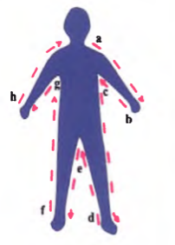
With the flat surface of the metal detector positioned parallel to the subject’s torso, scan full area of the torso, down to the lower front portions of the subject;s anatomy.
With the flat surface of the metal detector positioned parallel to the subject’s backside, scan the full area of the backside, down to the lower back portions of the subject’s anatomy.
Note: Scanning MUST NOT be done as a mere formality. Security personnel MUST stop and inquire about any items detected during screening. While the duties of conducting security screening often seems repetitious and fruitless, a thorough screening is necessary for an effective access control program.

References
ASTM, International, Standard Practice for Performance Evaluation of In-Plant Walk-Through Metal Detector, Retrieved from https://www.astm.org/Standards/C1309.htm
Security Pro USA, “Handheld Metal Detectors”, Retrieved from https://www.securityprousa.com/category/detection/security-metal-detectors

